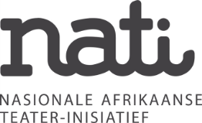
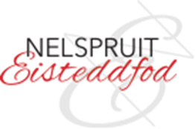
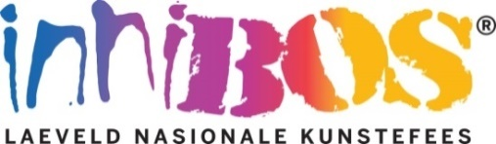

INNIBOS EISTEDDFOD MASTER CLASS

INFORMATION
1. The Innibos Eisteddfod Masterclasses will take place on Wednesday, 27 July 2022.
2. It will take place at Communio Church in Jacaranda Street, West Acres, Mbombela.
3. There are THREE master classes: 14:00 for English learners
16:00 for Afrikaans Primary School learners
18:00 for Afrikaans High School learners
4. Anyone may enter, but learners who are part of the Nelspruit Eisteddfod are given preference.
5. There is only room for 20 learners per master class.
6. The entry fee is R50 per person and must be paid into the following bank account to secure your place:
Lowveld National Arts Festival
STANDARD BANK
Cheque account
Branch code: 052 852
Account number: 042 344 190
Payment reference: EM + the child's name and surname.
7. Send the proof of payment and the entry form below to info@innibos.co.za
8. For any inquiries, call Philna Scholtz or Adelene Niehaus on 013 741-5294.

MORE ABOUT THE WORKSHOPS
These workshops offer an excellent opportunity for learners to prepare for their performance at the Nelspruit Eisteddfod. The master classes are presented by the well-known Kaz McFadden (see below for details). Some of the themes that will be covered are: use of the voice, voice projection, pronunciation, memorisation of texts, body language, self-confidence, speeches, film work, choice of texts, dialogues, how to control nerves and the business side of the entertainment industry. These workshops are sponsored by NATi (National Afrikaans Theater Initiative) and are part of Innibos's projects to promote the arts.

MORE ABOUT THE PRESENTER:
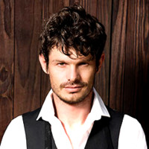 | Kaz McFadden is a well-known actor who has played roles in Binnelanders, Villa Rosa and 7de Laan. As a stage actor, he has been seen in various theatre productions such as Vaselinetjie and Iewers op die Grens. He has also achieved success behind the scenes as artistic director of Nomad Productions and as writer and director of Fladder, On the Other Side and many more. He has shown his exceptional talent in numerous films such as Die Wonderwerker, Knysna and Strikdas.  Kaz McFadden is not only a well-known actor but also a passionate lecturer and Managing Director of PALI Incubation, a training centre for actors, directors, producers and other creative souls. As a lecturer, he is actively involved in the entertainment industry in offering courses that are practical and industry-driven.  Students describe his presentations as “excellent” and “a special experience”.
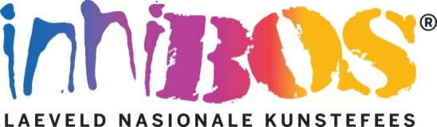
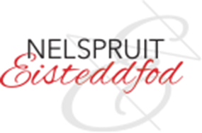
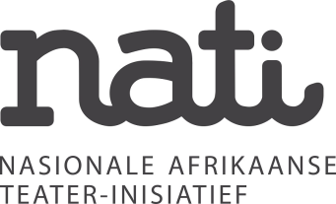

ENTRY FORM
DETAILS OF LEARNER:
Learner's name and surname:
In what grade is the learner?
Indicate with a cross which master class the learner will attend:
Wed 27 July 14:00  English class:  High- and Primary School learners |  | Wed 27 July 16:00  Afrikaans class:  Primary school  learners |  | Wed 27 July 18:00  Afrikaans class:  High school  learners
CONTACT DETAILS OF PARENT:
Parent's name and surname:
Cellphone number of parent:
Parent Email Address:

PAYMENT DETAILS:

Pay the R50 entry fee into the following bank account to secure your place:

Lowveld National Arts Festival
STANDARD BANK
Cheque account
Branch code: 052 852
Account number: 042 344 190
Reference: EM + the child's name and surname

Send the proof of payment and the entry form below to info@innibos.co.za

